Charters Towers
Gold Rush Triathlon
Sponsored by
Queensland Country Health Fund

Welcome athletes to the Queensland Country Health Fund - Charters Towers Gold Rush Triathlon 2018.

This is the first time that the NQTA have partnered with QCHF and we are happy to bring you something different.

We hope to grow this event year on year and as always we need the support of the local community.

As well as the QCHF we are fortunate enough to have some great friends in Charters Towers who call themselves the CT Tri and Adventure Mob, without which this event wouldn’t be happening at all - Thank you!

Charters Towers Regional Council have also been great as have the local police in making the administration pretty easy, and simple.

Lastly you the competitors - we thank you for your support and from all at the NQTA team and QCHF, we hope you have a great event.
Are you ready!?

Athlete Guide
May 6th
2018
Are you Ready?

Contents
1
Contents 1
Schedule of Events 2
PRE-EVENT INFORMATION 3
REFUND POLICY 3
EVENT BRIEFING 3
BAG DROP 3
CHECK IN 3
EVENT TIMING AND CUT OFF TIMES 3
PERSONAL SAFETY 3
SWIM CAPS 3
AFTER RACE 3
EVENT CHECK LIST - Suggested only 4
EVENT DAY Sunday 4TH March 5
Course Maps 6
Prize Giving 1

Schedule of Events
SWIM Clinic Saturday, May 5th 2018

Event | Location | Time
Swim Clinic, Free if you registered before the 1st Feb and $20 per head after | CT Pool | 15:00-17:00 Please pay pool fee on arrival
Junior competency swim test 400m unassisted - Compulsory safety requirement | CT Pool | 15:30 - 16:00 Please pay pool entry on arrival

Sunday May 6th, 2018
Event | Location | Time | Notes
Registration opens | Junction of Weir road and the Dirt Road at the end of Weir Road | 07:00 | Follow Weir road all the way to the end until you see the signs
Race Briefing - Junior Aquathon | Boat Ramp | 07:50
Junior Aquathon Start | Boat Ramp | 08:00
Race Briefing Adult Enticer - Adult Sprint - Individual Sprint | Boat Ramp | 08:30 | All competitors must attend this compulsory safety briefing
Adult Sprint and Teams Start | Boat Ramp | 08:45
Enticer Start | Boat Ramp | 09:00
Scratch Teams nominate - Free | Boat Ramp | 10:30 | Organise the scratch teams
Scratch Teams Race Sprint distance | Boat Ramp | 11:00 | 30 mins to organise and set yourself up – Cyclists to T2
Event Prize Giving for all events | Boat Ramp | 12:30 | May have the option to bring forward - dependent on last finisher
Please note if you want to leave the event area before the prize giving you will have a short window between 10:30 and 11:00, after which we will restrict traffic.

PRE-EVENT INFORMATION
This is an arduous event if you are moderately fit and have been training you should be able to finish this event. Please consult your doctor if you have any concerns prior to registering.

REFUND POLICY
Due to event costs there will be no refunds, you can elect to be entered in to another event, during the year. Should we have to cancel the swim due to a faster than normal flow then the race will continue as a Duathlon event.

EVENT BRIEFING
An event briefing will be as indicated in the schedule and will be covering all aspects of the Swim Bike Run course, athletes will receive event briefing 10 minutes before the start. Please make sure you arrive in promptly.

BAG DROP
Athlete bags can be left with event staff at the open water swim area at your own risk.

CHECK IN
The check in will be situated towards the end of Weir Road before you leave the bitumen. This will be in front of the bike transition area, so you can check in and register, you will also get numbered and then rack your bike here. You may then proceed to the swim start.

EVENT TIMING AND CUT OFF TIMES
The cut off time for all events will be 10am, this is for competitor safety.

PERSONAL SAFETY
Please ensure whilst you are on the course that you look after your own safety first. On the bike leg you adhere to all QLD road traffic regulations, as there is no full road closure. You must also have working brakes and your bike must otherwise be in a fully safe working condition. You must have an Australian standard marked approved helmet that is serviceable.

SWIM CAPS
If you wish to wear a swim cap please bring one with you as no swim caps will be provided on the day.

AFTER RACE
After the race there will be a mixture of fruit drinks and jelly’s available.

EVENT CHECK LIST - Suggested only
PRE EVENT  - Directions to Athlete check-In  - Directions to Race start  - Directions to Race finish  - Photo I.D.  - bike services/tune up  - Attend Athlete briefing  - study the race courses  EVENT DAY SWIM –  - GARMIN or lap counting device  - Swimsuit/Wetsuit (if applicable)  - Goggles (consider a spare pair as well)  - Swim cap  - Ear Plugs/nose Plug (optional)  - Morning clothes bag  EVENT DAY BIKE –  - Bike Pump  - Extra nutrition  - Extra Water bottles  - Aero Water bottle straw  - Bike Repair Kit bar-end plugs co2 cartridge(s)  - Spare tire spare tube  - Tyre levers  - Valve stem Extenders  - Patch Kit Wrench set/tools  - Body glide  - Sunscreen  - Helmet  - Sunglasses  - Bike shoes  - Socks  - GPs Watch or bike computer | EVENT DAY Run  - Fuel belt  - Hat/Visor  - Running shoes  - Socks  - Sunglasses  - Water bottle or belt if required  - Sunscreen  - Running shorts  MISCELLANEOUS  - Body Glide  - Antibacterial  - Contacts or Rx Glasses  - Heart Rate Monitor & chest strap  - Towel  - Hair ties  - Chopstick  - Post-Race clothing  - Have a Great Race!

EVENT DAY Sunday 6TH May
SWIM LEG – Open Water - Adult Sprint and Teams 750M - Enticer and juniors 350M
You are required to swim the distance you have nominated for along the open water course starting at the boat ramp. Please make sure you attend the athlete briefing. Swim equipment is not allowed for this event. There is no time limit to finish the open water swim event – and you will only be pulled from the water due to safety reasons. Safety craft will be all along the course. In the case of an emergency or if you have any problems please raise your hand above your head and wave. A support craft will come to your aid.

Juniors -
If you are a junior this is your second leg as you will be running first (See Run Leg below)
Run Leg - first leg
Juniors -
If you are doing the junior event this is your first leg - it’s a simple out and back course along the dirt track 1.25km to the signed turn point so you will cover 2.5km.

Adult Sprint 20KM (4 laps of 5k) - Teams (4 X laps of 5k) and Adult Enticer (2 laps 2.5k)

If you are doing the Adult Sprint - Teams or Enticer event - after your swim you will exit the ramp and turn immediately right and run along in front of the tents following the bunting / cones and dirt track you will run along the dirt track towards the bike area. When you reach the road you will continue running down the hill following the cones and around Weir part, back up the road to the bike area (T2) where you will get on your bike.

When you finish your bike you are to rack your bike on the opposite side of the bike rack next to the shoes you took off and start your last run which is the reverse of the run you did on the way out so starting down the hill and around the park back up the hill and along the dirt track, you will not be required to do the loop near the finish line but simply run down the ramp to finish’

Bike cut off time - Safety
This leg of the event is not timed - however the event will close at 10am and you will only be pulled off the course in the following circumstances:

- At your request
- For safety reason
- Medical reasons as observed by any event staff member
- Adverse weather conditions
- Closure of the event

Grouping and Drafting
Riding as a group and or drafting as a group is not allowed

Sag Wagon
There will be a sag (Safety vehicle) behind the last competitor. The Sag wagon can transport you back to the finish if required or help with mechanical problems. It will have a small first aid kit limited water and supplies. DO NOT rely on the Sag wagon to replenish your water as it will not do so unless there is a medical need.

Drinking bidon
You must start the bike leg with no less than 1 drinking bidon or the equivalent, replenishment will be on the run leg only.

RACE NUMBERS
You will be numbered both on your arm and on the calf, as this is a manual timed race you will be required to call out your number as you cross the finishing line, failure to do this clearly may risk your position and time not being recorded accurately. Remember there is prize money for the first 3 male and females,

Scratch Teams
After the main race has finished you get the opportunity to race for free and if your scratch team wins you walk away with $300 for your team, second and third placed teams will get an automatic entry to the Magnetic Island Triathlon in October, as individuals. You will nominate for a scratch team in any leg and we will put a team together, which could be a mixed team or of the same gender, it doesn’t matter. If we have more swimmers and not enough cyclists etc then we will ask you to change your nominated leg for the scratch team race so we can make the teams up. A full briefing will be given on the day.

Course Maps
The 350m Swim course will be a cut down version of the 750m Adult course

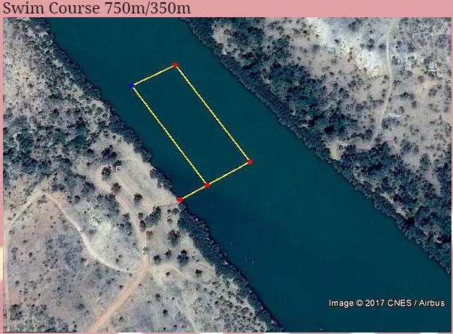

The junior course turn around will be 1.25km along the Adult Sprint course

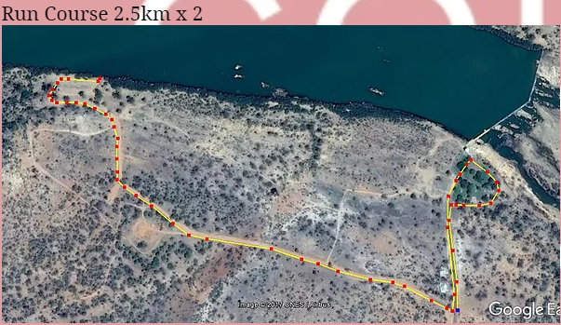

The Adult Enticer course turn around will be 2.5km along the Adult Sprint course
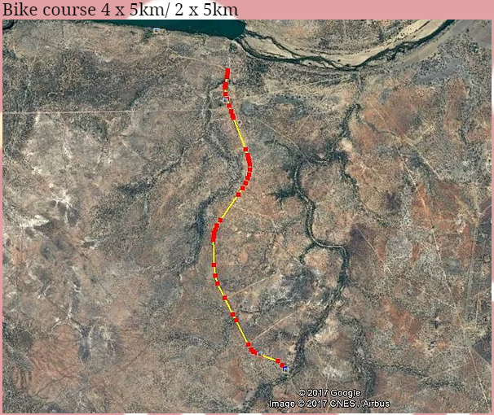

T2 - Transition to the bike
You will come on the first run in the direction of the blue arrow, run past the bikes down the hill and around the park, back up the hill on the left hand side of the road into T2,. The first thing you must do is don your helmet before you touch the bike, complete your change and push the bike to the mount dismount line. After you complete your ride you will come down the left hand side and rack again indicated by the blue arrow. Dismount on the line and push your bike and rack it opposite where you placed your shoes, complete your transition and exit in the same direction for the run

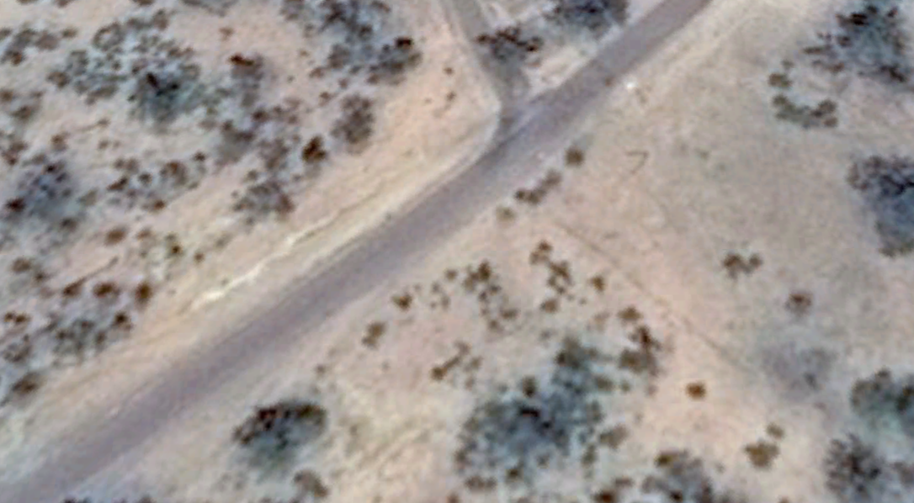
Rego - mount and dismount line
Bike Racks T2 - You will enter T2 up the hill from the run on the left get your bike and go

Prize Giving

Prize giving will be immediately after the last person has crossed the line and we have collated the winners.

Cash Prizes will be given for the following categories:

Adult Sprint: Adult Sprint Scratch Teams

1,2,3 Male and Female overall Overall prize only $300

Adult Enticer 2nd and 3rd placed teams
(free entry to Magnetic Island triathlon in October)
1,2,3 Male and Female overall

Adult Teams

1,2,3 Male and Female Teams

Junior Duathlon

1,2,3 Male and Female overall

